SEEDREAM 5.0
A Comprehensive Review
20 Great Use-Case Prompts with Sample Image Placeholders

March 2026

Table of Contents
1. Introduction: What Is Seedream 5.0?
2. Key Features and Improvements
3. How It Compares to Seedream 4.5
4. Prompt Structure Guide
5. 20 Use-Case Prompts with Sample Images
• Composite & High-Concept Photography (1–3)
• Data Visualisation & Infographics (4–6)
• Product & Commercial Design (7–9)
• Art, Illustration & Creative Styles (10–12)
• Logo & Graphic Design (13–15)
• Portrait & Technical Rendering (16–18)
• Food Photography (19–20)
6. Tips for Getting the Best Results
7. Limitations and Trade-Offs
8. Final Verdict

1. Introduction: What Is Seedream 5.0?
Seedream 5.0 is ByteDance’s flagship AI image generation model, released in early 2026. It represents a fundamental shift in how text-to-image models operate: rather than simply matching keywords to visual patterns, Seedream 5.0 attempts to understand the intent behind your prompt. It reasons through spatial relationships, applies world knowledge from science to architecture, and can even search the web in real time to pull in current information before generating an image.
Built on an advanced Diffusion Transformer (DiT) architecture with a high-compression VAE, the model generates images at up to 4K resolution. It unifies text-to-image creation and image editing within a single pipeline, which means you can generate an image and then refine it with natural language instructions without switching tools.
This review covers what Seedream 5.0 does well, where it falls short, and provides 20 carefully crafted prompts across seven creative categories so you can see the model’s capabilities in action.

2. Key Features and Improvements

Real-Time Web Search
This is the headline feature. Seedream 5.0 is the first model in the Seedream series that can access live web data during generation. When your prompt references trending topics, recent events, current product designs, or public figures, the model searches the internet before it draws. Time-sensitive keywords like dates, product names, and cultural references trigger this automatically. It means you can ask for “the 2026 Winter Olympics mascot” and get something grounded in reality rather than a hallucinated guess.

Intelligent Visual Reasoning
Seedream 5.0 doesn’t just draw; it thinks. The model handles multi-step logical reasoning, meaning it can work through spatial puzzles, understand physical orientation, and generate diagrams that reflect actual scientific principles. Ask it to visualise a quantum experiment, and it produces a logically accurate diagram rather than science-fiction nonsense. Ask it to arrange objects by size, and it gets the ordering right.

Unified Generation and Editing
The model combines image generation and image editing in a single architecture. You can generate an image, then ask for targeted modifications using natural language: change the lighting, swap the background, shift the focal point, or adjust individual elements. It supports both brush-based masking and text-based instructions, and it maintains consistency across unedited regions.

Enhanced Character Consistency
Maintaining a character’s appearance across multiple generations has been one of AI’s persistent challenges. Seedream 5.0 tackles this with improved identity-retention mechanisms. Facial features, expressions, clothing, and accessories stay consistent across different poses, angles, and lighting conditions. This is critical for brand campaigns, serial storytelling, and product catalogues.

Improved Text Rendering
The model handles bilingual typography in English and Chinese with clearer structure, better spacing, and stronger readability at small sizes. While not perfect, it’s a meaningful step forward for poster designs, UI mockups, and any visual that needs legible text.

4K Native Resolution
Seedream 5.0 generates natively at 2K and 4K resolution. Fine details remain sharp even at full enlargement, making output suitable for print, advertising, e-commerce listings, and large-format digital displays.

3. How It Compares to Seedream 4.5
Seedream 4.5 was the “complete form” of the 4.0 architecture: it cleared obstacles in image quality and resolution, achieving strong results in text rendering and multi-image consistency. Seedream 5.0 builds on this foundation but targets an entirely different dimension: intelligence.
Feature | Seedream 4.5 | Seedream 5.0
Web Search | No | Yes – real-time
Visual Reasoning | Basic in-context | Multi-step logical
Max Resolution | 4K | 4K
Text Rendering | Good | Better (bilingual)
Character Consistency | Strong | Stronger
Unified Edit + Generate | Yes | Yes (enhanced)
Photorealism | Excellent | Good (trade-off for intelligence)
Material Textures | Strong | Weaker (flatter)

The key takeaway is that Seedream 5.0 trades some photorealistic polish for substantially more intelligence. If your workflow demands razor-sharp skin textures and material depth, version 4.5 still has the edge. If you need the model to reason through a complex brief, pull in current information, or handle multi-step compositions, 5.0 is the clear choice.

4. Prompt Structure Guide
Seedream 5.0 responds best to prompts built on five pillars: Subject, Composition, Style, Lighting, and Technical Parameters. Here’s how each works:
Element | What It Controls | Example
Subject | The primary focus of the image | A ceramic coffee mug on a wooden table
Composition | Framing, angle, and spatial layout | Top-down flat lay, centred, with negative space
Style | Visual anchor – genre, medium, or era | Minimalist product photography, matte finish
Lighting | Source, quality, colour temperature | Soft diffused window light from the left
Technical | Resolution, finish, exclusions | 4K, shallow depth of field, no text overlays

You don’t need to include every element in every prompt, but the more specific you are about composition and lighting, the more control you’ll have over the result. Seedream 5.0’s web search triggers automatically when your prompt includes recent dates, product names, events, or trending terms.

5. 20 Use-Case Prompts with Sample Images
Below are 20 prompts organised across seven creative categories. Each prompt is designed to showcase a specific strength of Seedream 5.0. The image placeholders indicate where the generated sample image should be placed.

Category A: Composite & High-Concept Photography
These prompts test Seedream 5.0’s ability to combine multiple scenes, locations, or visual systems within a single frame. They require spatial reasoning and compositional intelligence.
1. Four Seasons Mountain Valley
Prompt: High-concept composite photography. A single mountain valley scene divided into four equal vertical panels, each showing the same location in a different season. Far left: deep winter with bare trees, thick snow, grey overcast sky, frozen lake. Centre-left: early spring, cherry blossoms opening, soft morning light, pale green grass. Centre-right: full summer, dense green canopy, bright midday sun, wildflowers in the foreground. Far right: late autumn, rich orange and red foliage, golden hour light, fallen leaves on the path. Seamless colour transitions between each panel. Photorealistic, wide-angle, deep depth of field, 8K resolution.

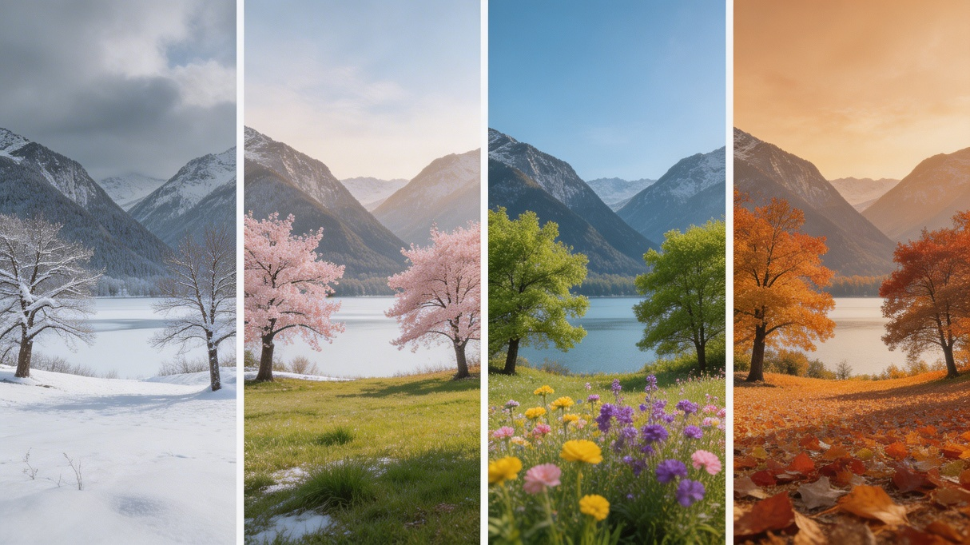
Four Seasons Mountain Valley Composite
2. Five-City Weather Composite
Prompt: Search for the current weather for Beijing, New York, Tokyo, Sydney, and Madrid. High-concept composite photography. The image is composed of five seamlessly stitched vertical panoramic strips. Each strip presents the real-time weather and lighting of a specific location: far left (Beijing): the Bird’s Nest Stadium. Left-centre (New York): Manhattan skyscrapers. Centre (Tokyo): Tokyo Tower. Right-centre (Sydney): the Opera House. Far right (Madrid): the Royal Palace. Use cinematic colour grading to unify the image. High contrast, 8K resolution, photorealistic masterpiece.

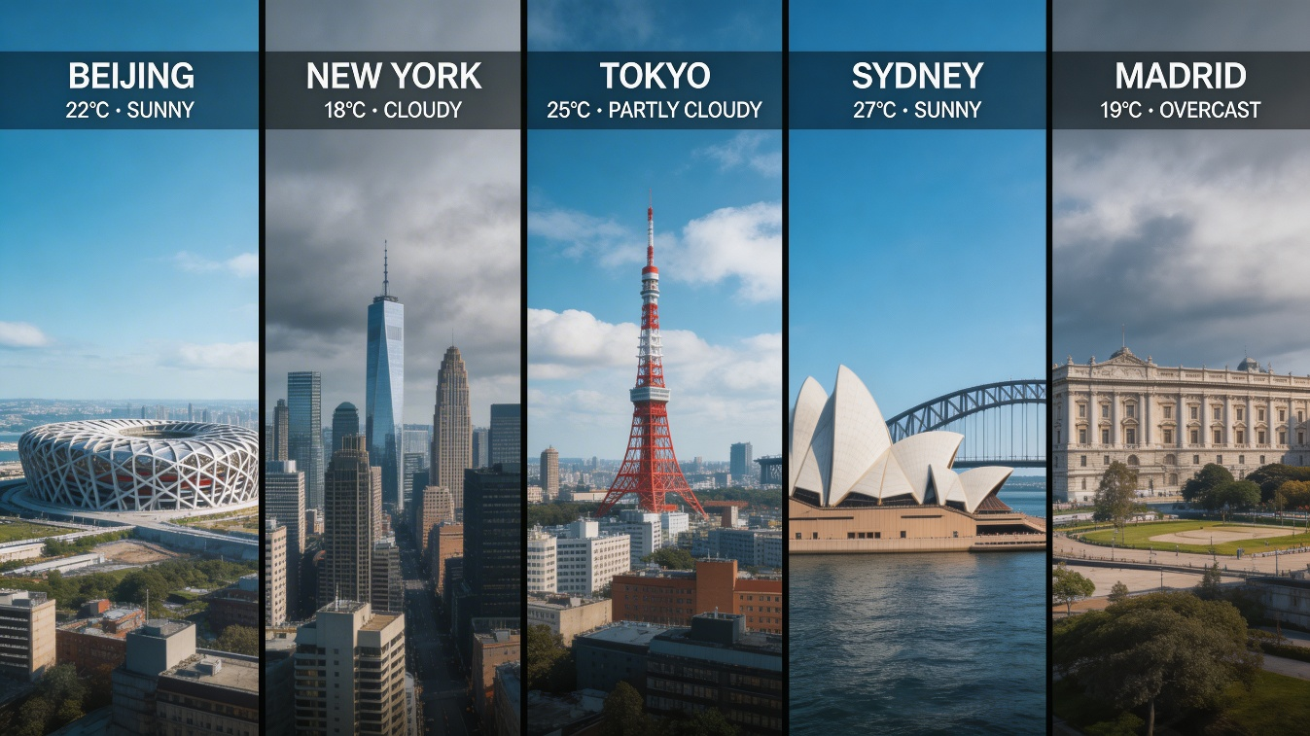
Five-City Real-Time Weather Composite
3. Day-to-Night Urban Transition
Prompt: A wide panoramic cityscape of a waterfront skyline divided into three seamless horizontal bands. The top third shows golden hour with warm amber light hitting the upper floors of buildings. The middle third captures blue hour with deep indigo sky and the first city lights appearing. The bottom third shows full night with neon reflections on the water surface. All three bands share the same skyline and composition. Photorealistic, ultra-wide aspect ratio, 8K resolution, no text.

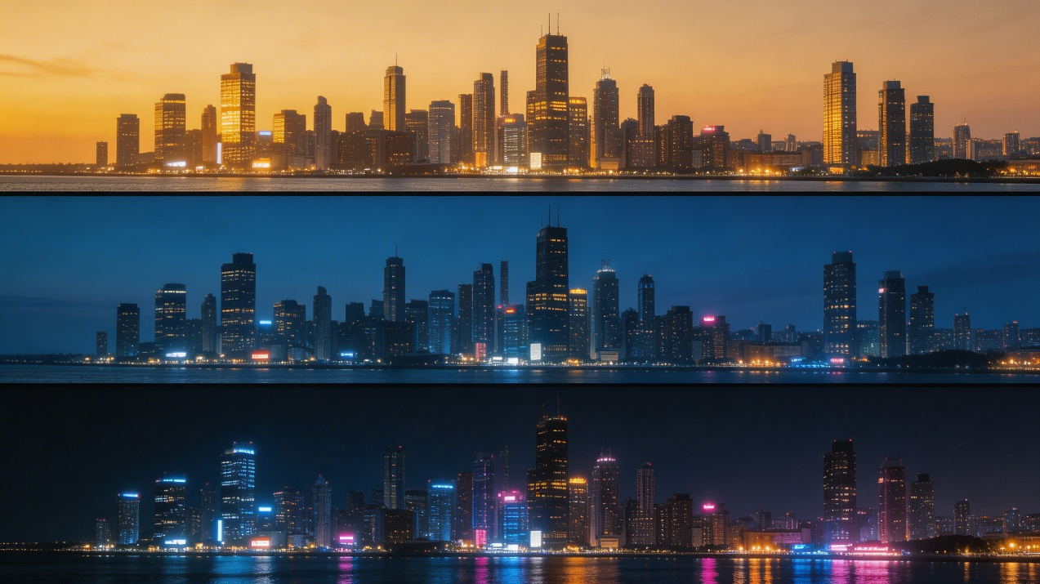
Day-to-Night Waterfront Transition

Category B: Data Visualisation & Infographics
These prompts leverage Seedream 5.0’s reasoning capabilities and world knowledge to turn structured information into visual formats, ideal for social media, educational content, and explainer graphics.
4. Glassmorphism Analytics Dashboard
Prompt: A clean social media analytics dashboard displayed as a single UI card. Dark mode background with a neon green accent line graph showing follower growth over 30 days. Each data point is labelled with a value. A percentage growth badge sits in the top right corner. Platform icons line the bottom axis. Glassmorphism card style with a soft inner glow. 4K resolution. No watermarks, no extra UI elements outside the card boundary.

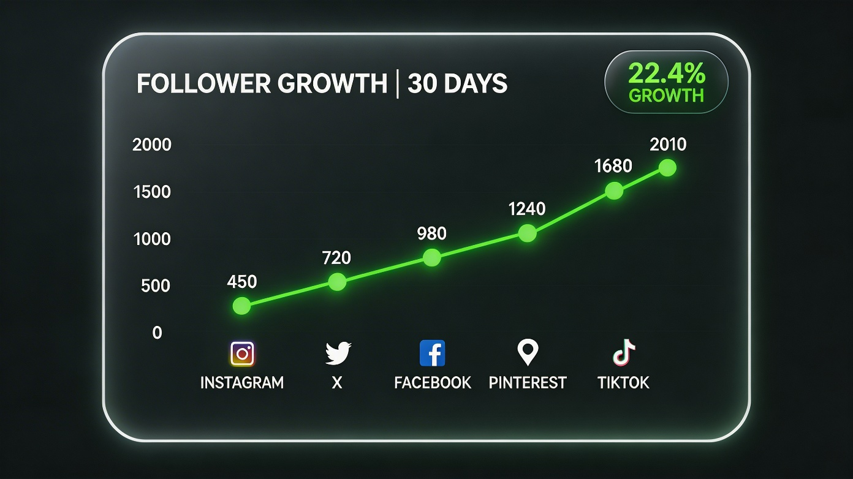
Glassmorphism Social Analytics Dashboard
5. Campaign Mind Map
Prompt: A professional mind map for a “Kitchen Helper” marketing campaign for small home appliances. Three primary category branches with hand-drawn icons next to each. Each secondary branch lists three main product features. Clean layout on a white background, subtle colour coding per branch, professional and modern aesthetic. High resolution, no clutter.

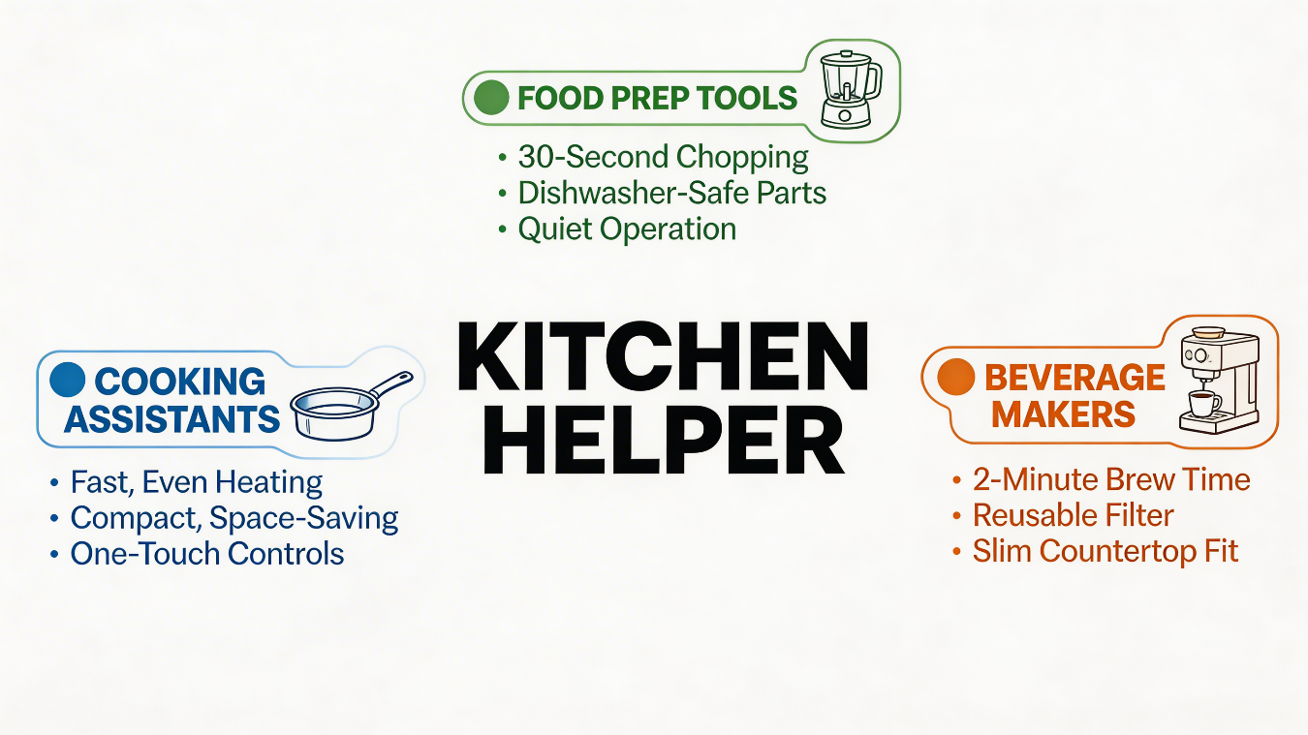
Kitchen Helper Campaign Mind Map
6. Nutrition Infographic Plate
Prompt: A top-down photograph of a balanced meal on a white plate, with clean annotation overlays showing the calorie content of each food item. Each annotation is connected to its food with a thin line. Semi-transparent label boxes with white text on dark backgrounds. The plate includes grilled salmon, steamed broccoli, brown rice, and a side salad. Soft studio lighting from above. 4K resolution, no extra text outside annotations.

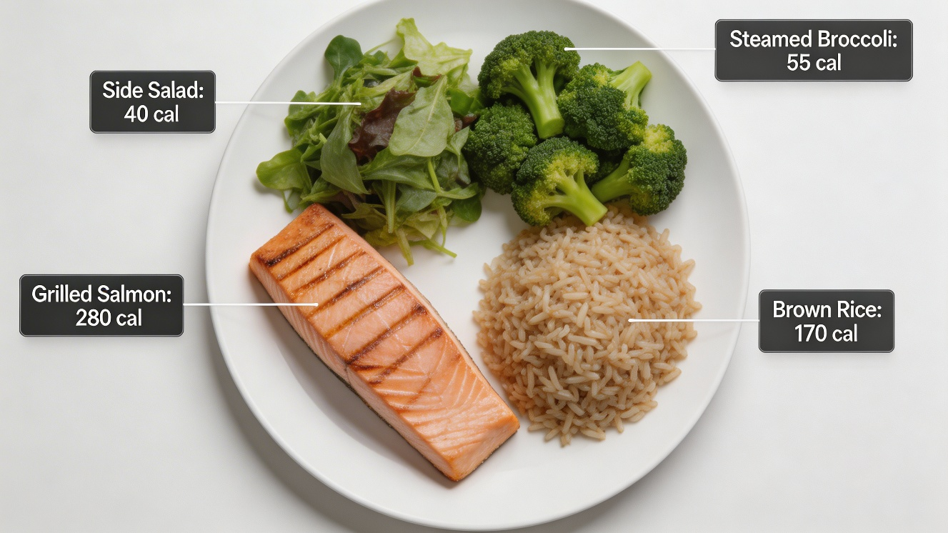
Annotated Nutrition Infographic Plate

Category C: Product & Commercial Design
These prompts generate branded and promotional images suitable for e-commerce, product launches, and advertising campaigns.
7. Luxury Skincare Flat Lay
Prompt: A styled flat lay for a luxury skincare brand. White marble surface. Three glass skincare bottles arranged in a loose triangle formation. Fresh botanicals and dried flowers placed naturally between the bottles. Soft diffused window light from the left side. Pastel pink and cream colour palette. Overhead shot, centred composition. 4K resolution, shallow depth of field on botanical elements, sharp focus on product labels. No text overlays, no extra props.

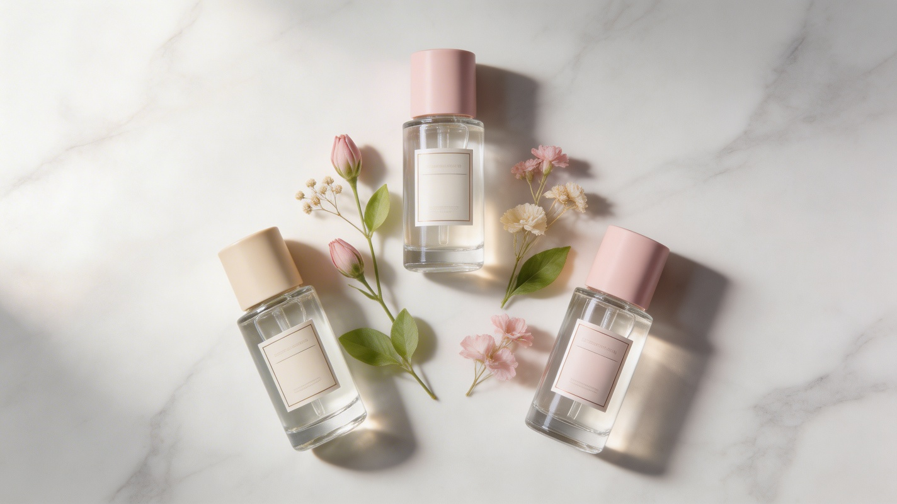
Luxury Skincare Product Flat Lay
8. Hotel & Resort Promotional Poster
Prompt: A modern travel hotel and resort promotional poster layout. Dark navy-teal background with a subtle diagonal diamond grid texture and thin white wavy lines across the top corners. The headline ‘Hotel & Resort’ in large white, rounded, bold display type. A collage of three masked photographs showing a pool, a suite interior, and a beach sunset. Contact details in small type at the bottom. High-resolution vector graphic design, crisp edges, print-ready.


Hotel & Resort Promotional Poster
9. Artisan Coffee Label
Prompt: Minimalist product label design for an artisan coffee brand called “Still Morning”. White background. A single hand-drawn coffee branch illustration in the upper half, black ink line art style. Below it the brand name in a clean serif typeface, small and precisely spaced. A thin circular border frames the entire composition. At the bottom, a one-line descriptor in light grey: “Single Origin, Slow Roast.” No gradients, no photography, no decorative patterns. Print-ready, high resolution.

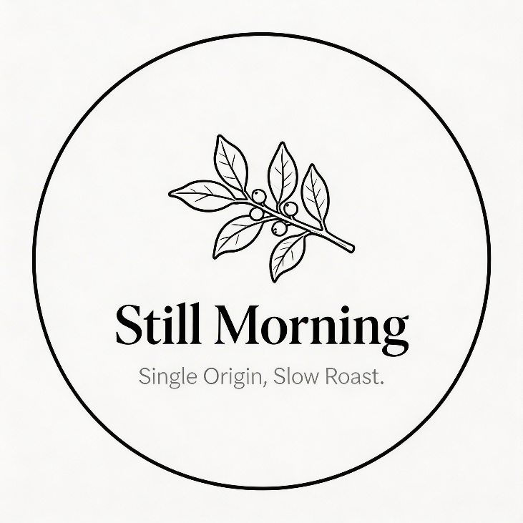
Still Morning Coffee Label Design

Category D: Art, Illustration & Creative Styles
These prompts prioritise style, technique, and visual treatment. They work well for editorial illustration, creative campaigns, and personal projects where aesthetic distinctiveness matters.
10. Two-Colour Risograph City Night
Prompt: Risograph print illustration of a retro city street at night, using only two colours: Neon Orange and Teal. No other colours in the image. Visible paper grain texture, slight registration offset between colour layers. A corner convenience store glows in orange light, with teal shadows falling across the empty street. Overhead power lines cross the composition diagonally. Flat colour fills, no gradients, print aesthetic.

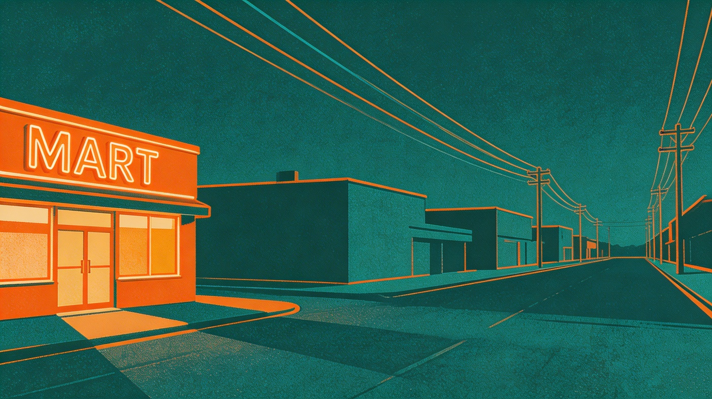
Two-Colour Risograph City Night Scene
11. Botanical Scientific Illustration
Prompt: 19th-century botanical scientific illustration of a tropical flowering plant, centred with fully exposed roots and a marked soil line. Circular inset diagrams of flower detail, leaf cross-section, and seed pod interior. Fine ink linework with soft watercolour on aged cream parchment. Handwritten Latin labels with delicate annotation lines. Vintage engraving style, no modern fonts, no digital look.

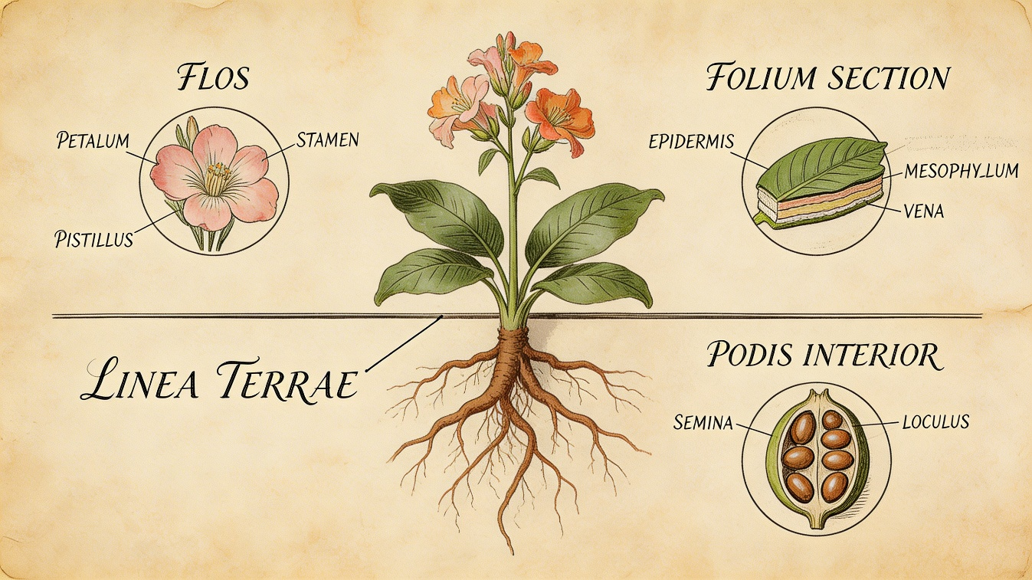
Vintage Botanical Scientific Illustration
12. Silver Butterfly Movie Poster
Prompt: Vintage film grain, liquid silver metal with irregular distribution around the frame. A silver metal-texture butterfly, horizontally and vertically centred. Creative artwork with metallic luminous texture, ghosting dispersion effect. Pure black film grain noise background. Minimalist style, movie poster composition. Below the butterfly: movie information text in elegant typography. Fault and dispersion effects throughout.

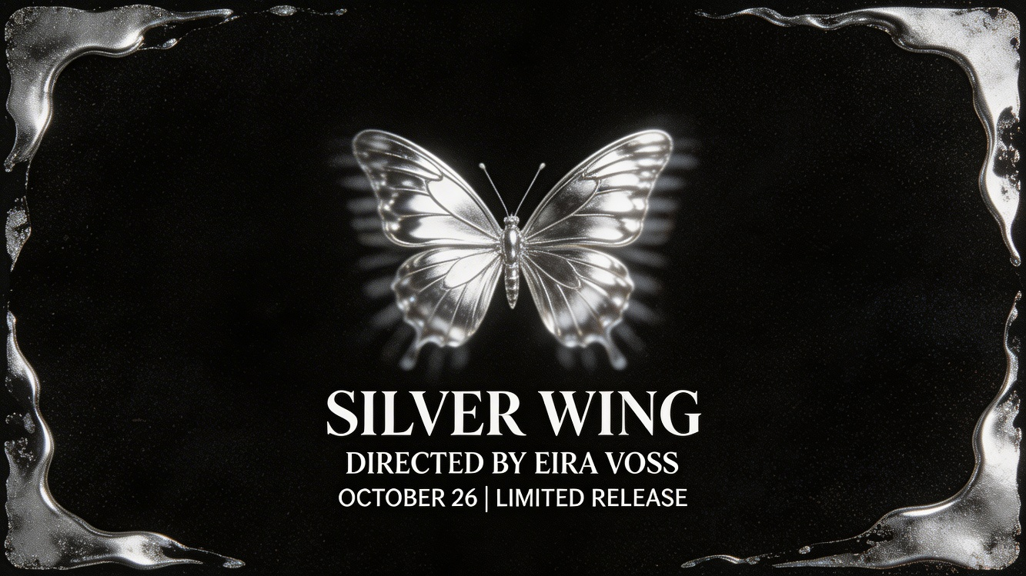
Silver Butterfly Movie Poster

Category E: Logo & Graphic Design
These prompts create clean, concept-driven designs for brand identity, typographic compositions, and minimalist visual communication.
13. Plant Killer Logo
Prompt: Minimalist logo design, centred composition, black background. A white circle with radial lines radiating outward from the centre. Bold creative typeface displaying the text ‘Plant Killer’ in the centre of the circle. Small descriptive English slogan text arranged around the title. Strictly black and white colour palette. Cold, modern, graphic design aesthetic.

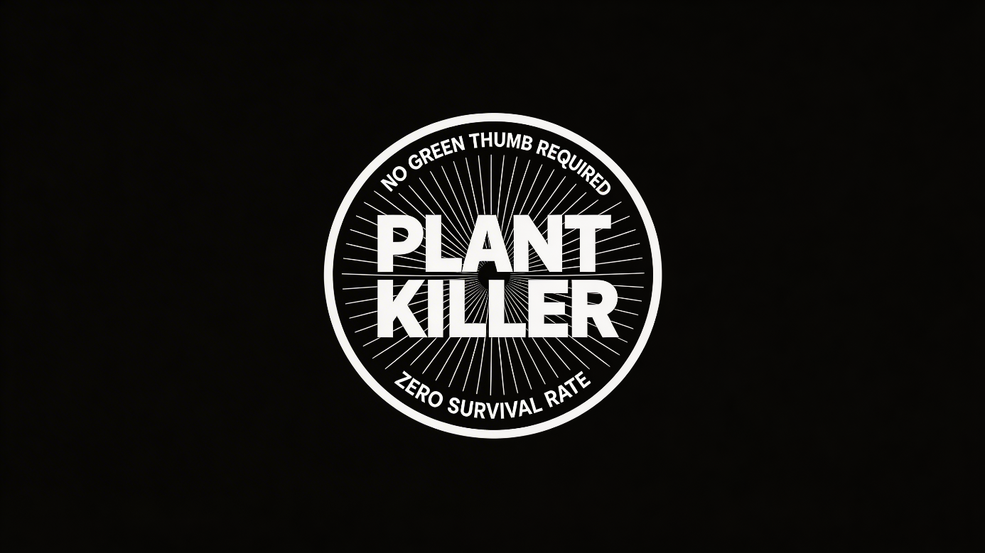
Plant Killer Minimalist Logo
14. Geometric Podcast Cover
Prompt: A podcast cover design. Square format, 3000x3000 pixels. Deep charcoal background. A single large geometric shape – an irregular polygon – filled with a warm gradient from burnt orange to gold, positioned slightly off-centre to the right. The podcast title “Slowburn” in a thin sans-serif font, white, aligned left in the upper third. A short tagline beneath in smaller grey text: “Stories that take their time.” No photography, no extra decorative elements. Clean and modern.

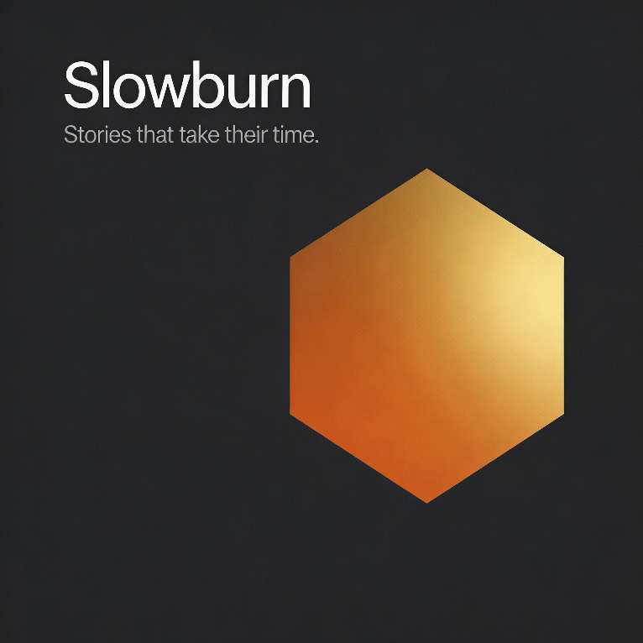
Slowburn Podcast Cover Art
15. Vintage Museum Sticker Pack
Prompt: Vintage museum-themed handbook stickers featuring ancient artefacts, fossils, sculptures, and other elements. Retro tones with sepia, rust, and aged gold hues. Grainy textures capturing the passage of time. Multi-layered stickers and collage elements surround the composition. Sticker borders feature bright white die-cut edges. Dopamine-style aesthetics, high resolution, hand-drawn feel. Suitable for journaling enthusiasts and culture lovers.

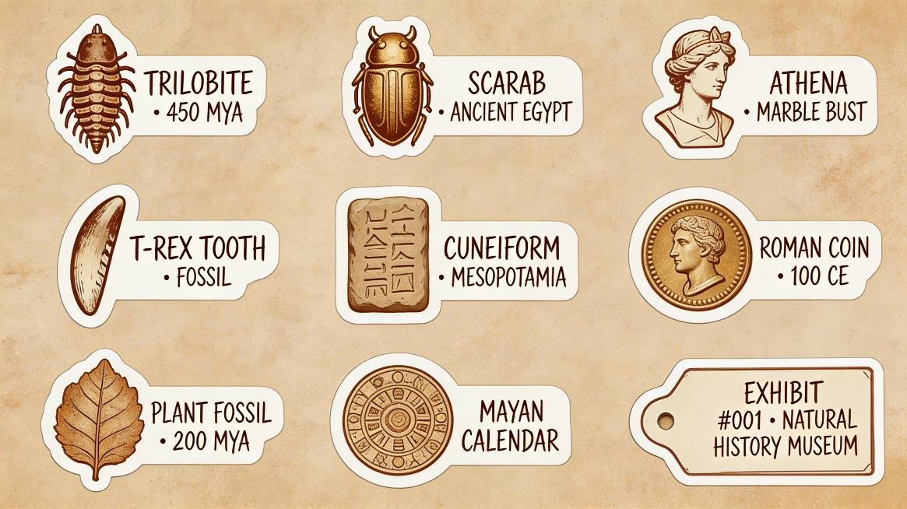
Vintage Museum Sticker Collection

Category F: Portrait & Technical Rendering
These prompts test Seedream 5.0’s precision with surface detail, realistic lighting, and technical accuracy.
16. Translucent Material Study Grid
Prompt: A technical rendering study on a dark studio background. A 3x3 grid of identical cube shapes, each made from a different translucent or semi-transparent material: frosted glass, amber resin, tinted acrylic, cloudy quartz, rose-tinted gelatin, cobalt blue glass, smoked perspex, clear crystal, and green sea glass. Uniform three-point studio lighting across all cubes. Each cube casts a slightly different shadow and light refraction pattern based on its material. No labels, no background texture, photorealistic render quality.

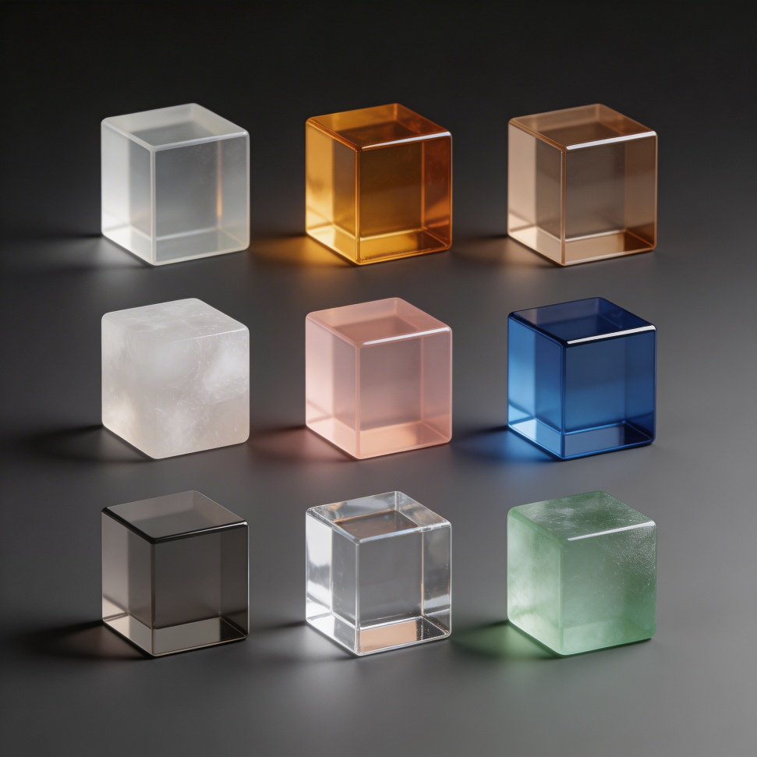
Translucent Material Study Grid
17. Fashion Editorial Portrait
Prompt: Vibrant close-up editorial portrait. Model with a piercing gaze, wearing a sculptural hat. Rich colour blocking with complementary tones. Sharp focus on eyes, shallow depth of field. Shot on medium format. Dramatic three-point studio lighting with a strong key light from the upper left and a cool rim light on the right. 4K resolution. No background clutter.


Fashion Editorial Portrait
18. Roughness Sphere Progression
Prompt: A row of seven identical spheres on a neutral grey surface, under uniform studio lighting. Roughness gradually increases from left to right: the leftmost sphere is perfectly mirror-polished chrome, the middle sphere is brushed metal, and the rightmost sphere is rough unfinished stone. Each sphere reflects the environment differently based on its surface roughness. Clean render, no text, no background distraction.

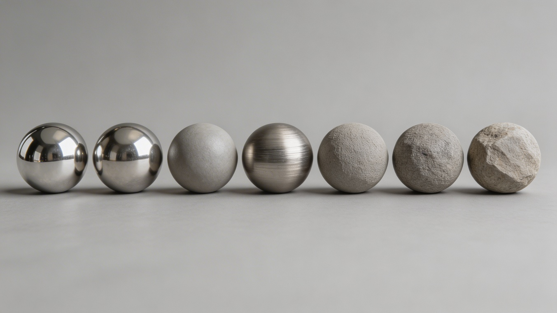
Material Roughness Sphere Progression

Category G: Food Photography
These prompts generate sensory-driven images where texture, colour, and detail take centre stage. Ideal for food brands, recipe content, and restaurant marketing.
19. Slow Honey Pour Macro
Prompt: Extreme macro photography of honey being poured from a wooden dipper onto a slice of toasted sourdough bread. The honey strand catches warm backlight, showing its amber transparency and slow viscous movement. Tiny air bubbles are visible inside the pour. The bread texture is sharp and detailed in the foreground. Background is soft with warm kitchen tones. Natural morning window light from the right. 4K resolution, shallow depth of field, no text, no extra props.

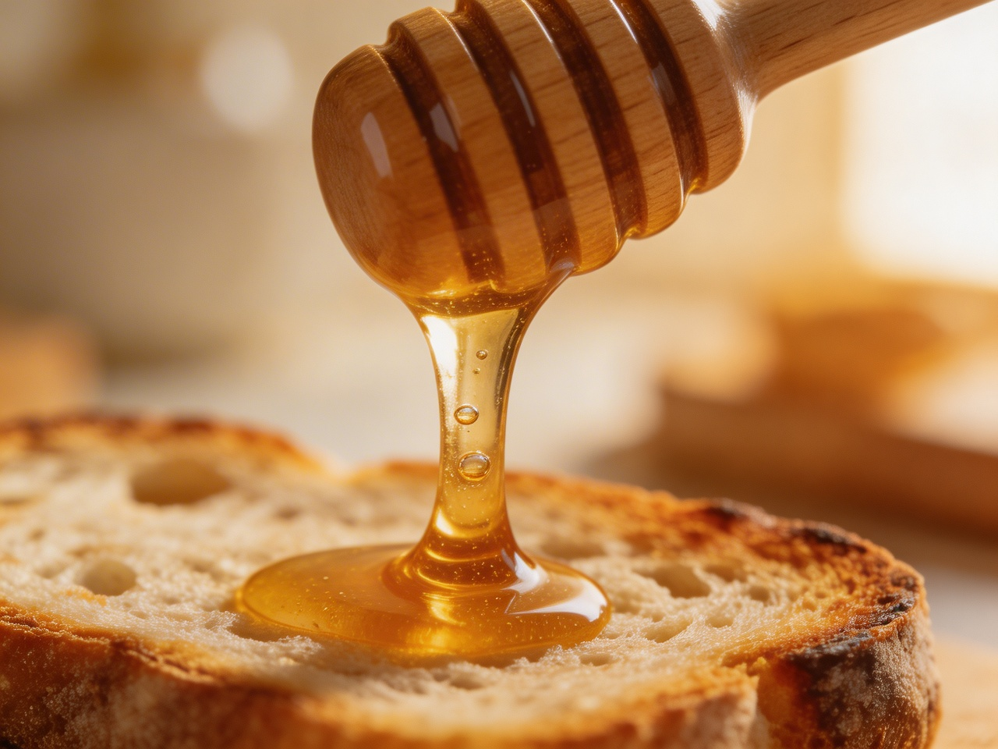
Slow Honey Pour Macro Shot
20. Omakase Sushi Platter Overhead
Prompt: Overhead flat lay photography of a premium omakase sushi platter on a dark slate surface. Eight pieces of nigiri arranged in a precise arc. Each piece is distinct: tuna, salmon, yellowtail, sea urchin, scallop, prawn, wagyu, and ikura. Microgreens and shiso leaves placed between pieces. A small ceramic dish of soy sauce sits at the bottom right. Soft directional studio light from the upper left. High resolution, sharp focus across all pieces, no steam, no condensation, no extra props.

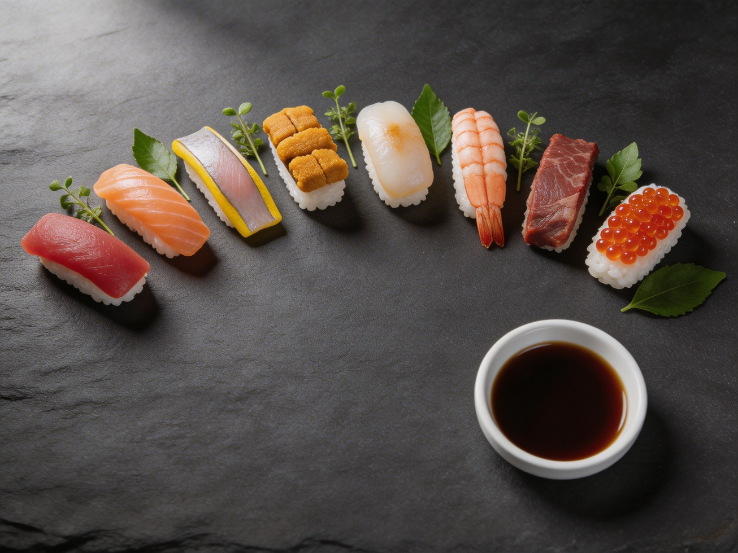
Premium Omakase Sushi Platter

6. Tips for Getting the Best Results
1. Lead with the subject. State your primary focus in the first sentence. Everything else supports it.
2. Be specific about lighting. Seedream 5.0 responds well to precise lighting descriptions. “Soft diffused window light from the left” gets better results than “nice lighting.”
3. Use exclusions deliberately. “No text, no watermarks, no extra props” helps prevent the model from adding unwanted elements.
4. Trigger web search when you need it. Include dates, product names, or trending terms if you want the model to pull current information.
5. One style anchor per prompt. Mixing too many styles confuses the output. Pick one visual anchor and commit to it.
6. Specify resolution and format. “4K resolution” and “wide-angle” give the model clear technical parameters to work within.
7. Iterate with editing. Generate first, then refine with Seedream’s built-in editing. Change lighting, swap backgrounds, or adjust individual elements with natural language instructions.

7. Limitations and Trade-Offs
No model is perfect, and Seedream 5.0 makes deliberate trade-offs to achieve its intelligence gains. Here’s what to watch out for:
Photorealism has regressed slightly. Images can look more obviously AI-generated compared to Seedream 4.5. If you need hyper-realistic skin textures or product photography that passes as a real photo, version 4.5 may still be the better choice.
Material textures are flatter. Fabrics, metals, and wood grain lack the depth and tactile quality of earlier versions. Design work requiring convincing material renders may disappoint.
Text rendering is improved but still inconsistent. Small text can still appear distorted or repeated. For designs with heavy typography, expect to iterate or handle text in post-production.
Web search is probabilistic. It doesn’t trigger every time, and when it does, the results aren’t always accurate. Always verify time-sensitive content.
Human proportions can be unpredictable. While anatomy accuracy has improved, complex poses and foreshortening still occasionally produce odd results.

8. Final Verdict
Seedream 5.0 represents a genuine shift in what AI image generation can do. It’s not just a better paintbrush; it’s a smarter one. The combination of real-time web search, multi-step visual reasoning, and unified generation-plus-editing makes it the most capable model in ByteDance’s lineup for complex, context-dependent creative work.
The trade-off is clear: you give up some photorealistic polish in exchange for substantially more intelligence. For marketing campaigns that need current references, educational content that needs factual accuracy, complex composites that need spatial reasoning, or any workflow where you need the model to understand your intent rather than just match your keywords, Seedream 5.0 is the right tool.
For pure photorealism and material fidelity, Seedream 4.5 remains a strong option. The two versions complement each other well, and the smartest approach may be to use both: Seedream 5.0 for composition and conceptual work, then 4.5 for final rendering when photographic quality is the priority.

End of Review

